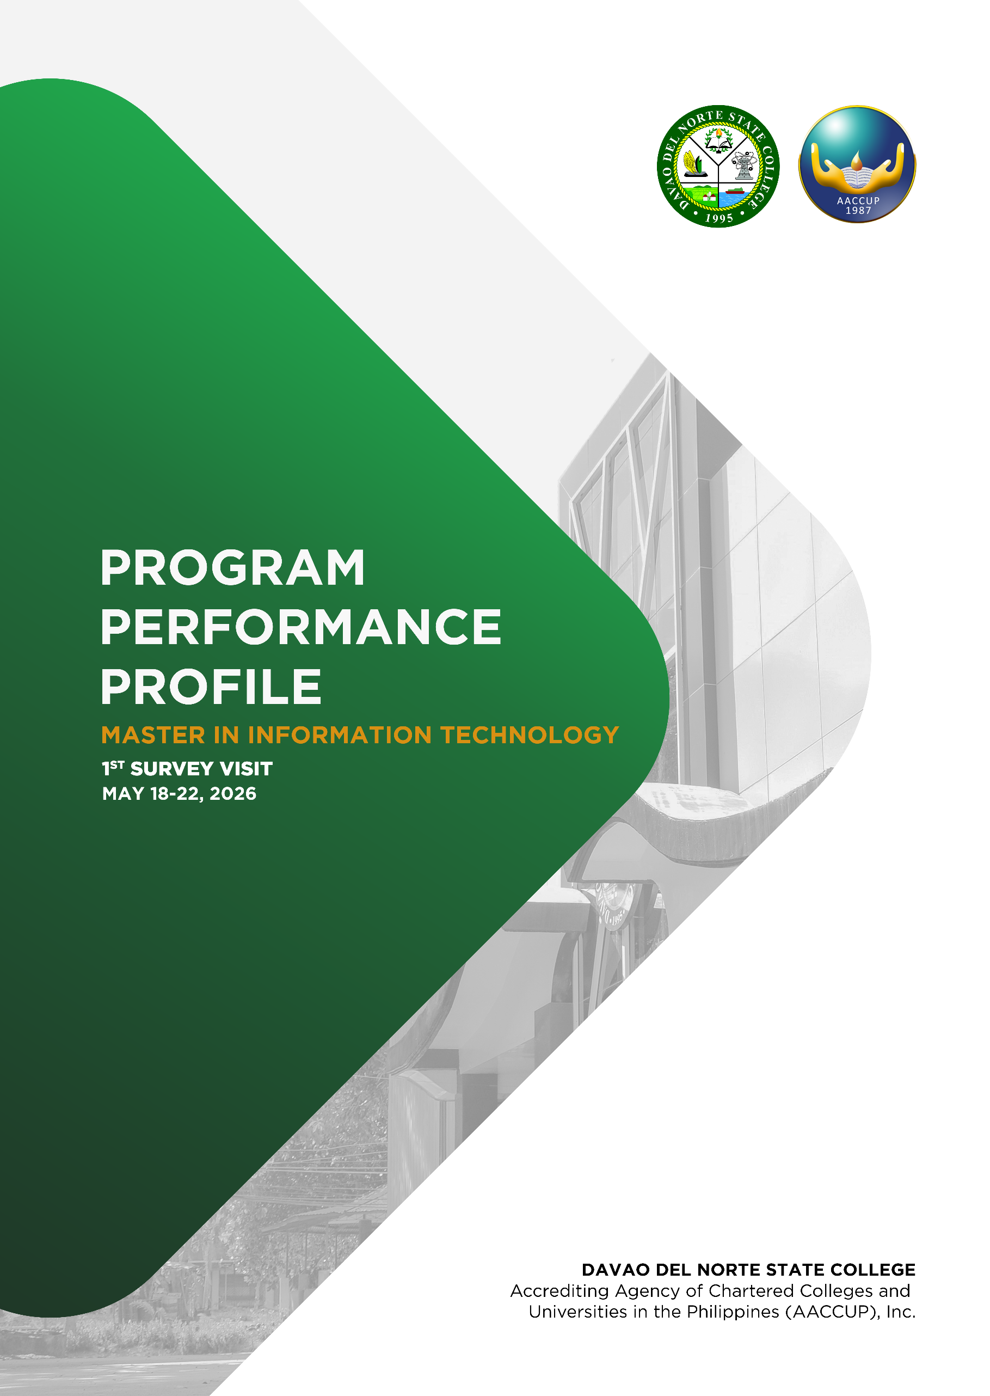

.



Name of Program
Academic College and Department/ Institute/School where the program is part: | Master in Information Technology
Name of SUC | Davao del Norte State College
Location of the Main Campus | New Visayas, Panabo City, Davao del Norte
Head of the Program | Dr. Hazel A. Gameng
Dean of the Institute | Dr. Nickel Jean L. Sastine
President of SUC | Dr. Joy M. Sorrosa
Legal Basis of the Program | CMO No. 07, series of 2020  CMO mo.15, series of 2019  BOT Resolution no. 43. Series of 2021
Date of Opening | 1st sem August 2022
Accreditation Visit Being Applied for | 1st Survey Visit
Present Accreditation Status and its Inclusive Period of Effectivity


AREA 1
VISION, MISSION, OBJECTIVES, AND GOALS

Parameter A: Statement of the Vision, Mission, Goals and Objectives
dfdf

- SYSTEM – INPUTS AND PROCESSES

  - State the Vision of the University/College

    - DNSC Vision (2025-2029)

“An Institution leading in Agri-Fisheries and Socio-cultural Development in the ASEAN Region”

The Davao del Norte State College aspires to become a higher education institution which would lead the futures of Agri-Fisheries and Sociocultural Development, with Technological Advancement as the third supporting niche; first in the Davao Region, then in the national stage, and forward towards the ASEAN Region - and beyond.

    - DNSC Vision (2020-2024)

“A premiere Higher Institution in Agri-Fisheries and Socio-cultural Development in the ASEAN Region”

Davao del Norte State College envisions being one of the pillars of higher education system by becoming a premier higher institution that provides Agri-Fisheries and Socio-Cultural development in the ASEAN region.

To attain this, the College strives to become a University with recognized center of development and/or excellence in specialized discipline; to be a beacon of knowledge; to lead innovation on uplifting lives of every Filipino family; and to be a strong advocate of nature preservation especially the agriculture and aquatic resources of the country and beyond.

  - State the Mission of the University/College

    - DNSC Mission (2025-2029)

“DNSC shall produce future-ready workforce, create Innovative solutions and technologies, empower communities, and uphold good governance towards sustainable development.”

The College’s mission is aligned with our mandate, as stipulated in our Charter (RA 7879), which is to “primarily provide higher professional, technical, and special instructions for special purposes and promote research and extension services, advanced studies and progressive leadership in education, engineering, arts, sciences, fisheries, and other fields as may be relevant.

    - DNSC Mission (2020-2024)

“DNSC strives to produce competent human resources, generate and utilize knowledge and technology, uphold good governance and quality management systems for sustainable resources and resilient communities.”

The College strives to achieve greater goals into becoming a University that upholds high standards in education, research, extension and production. Particularly, the College commits to:

          - deliver in the areas of instruction, research, extension and production, and good governance;
          - influence development through research, extension and production in collaboration with stakeholders; and
          - uphold good governance and quality management system through optimum participation, accountability, transparency and adherence to the rule of law.

  - State the Goals of the Academic Unit

    - DNSC Goals (2025-2029)

GOAL 1 - Curriculum and Instruction: Cultivate a Dynamic and Inclusive Learning Environment for a Globalized Future
GOAL 2 - Research, Development, and Extension: Foster a Culture of Innovation and Collaboration in Research, Development, and Extension
GOAL 3 - Administration and Resource Management: Enhance Institutional Effectiveness and Sustainability through Integrated Initiatives

    - DNSC Goals (2020-2024)

Align with its vision and mission, the College aims to achieve the following:

          - provide equitable access to quality and relevant programs that promotes inclusive development;
          - undertake socially relevant, environmentally friendly and economically beneficial extension and production activities anchored on robust researches;
          - foster dynamic partnerships with the local, national, international community; and
          - ensure high accuracy, compliance with applicable standards, and high customer satisfaction.

  - State the Objectives/Outcomes of the Program

    - Program Educational Objectives

The educational objectives of the Master in Information Technology graduate program in Davao del Norte State College are to prepare graduates who, after five years of their professional career, can:

- Develop, use and integrate emerging technologies into IT-based solutions in the core information technologies of networking, data management, software engineering, computer security.
- Demonstrate a deep recognition and adherence of the advanced IT methodologies and frameworks used to solve complex computing problems integrating the industry-recognized best practices and standards.
- Pursue continuing professional development and present and publish at least one research output related to at least one IT Body-of-Knowledge.

    - Program Outcomes

The following are the student outcomes of the Master in Information Technology graduate program in Davao del Norte State College. These are expected from students by the time of their graduation:

MIT01. Identify user needs, create an effective project plan, and effectively integrate IT-based solutions into the user environment.

MIT02. Analyze a problem, design and implement IT-based solutions and appropriate computing requirements to meet desired needs.

MIT03. Use current techniques and apply computing skills and techniques appropriate to the core of information technologies.

MIT04. Perform and communicate effectively with a range of audiences to accomplish goals for continuing professional development.

MIT05. Adhere to the professional, ethical, legal, security, social issues, and responsibilities, and analyze the local and global impact of computing on individuals, organizations, and society.

  - Illustrate and describe the historical formulation, monitoring, and review of the VMGO.

    - VMGO (2025-2029)

On April 04, 2024, the Office of the College President issued Office Special Order No. 127, series of 2024, constituting the Editorial Board, KSA Task Force, and Plan Writers for the DNSC Strategic Development Plan for 2025-2029. After such issuance, the Pre-Planning and Strategic Planning activities immediately commenced. Pre-planning activities involved the conduct of Benchmarking, Environmental Scanning, and Legal and Regulatory Compliance. In the strategic planning phase, various workshops were conducted.

The first workshop was conducted on April 18-19, 2024, for the initial formulation of the institution's vision, mission, goals, and core values (VMGO). Workshop 2 was conducted on three separate occasions: the Research, Extension, and Production cluster convened on May 10, 2024, the Administration and Finance cluster met on May 13, and the Instruction cluster followed on May 17. Workshop 2 focused on the Identification of Strategies, Programs, Activities, and Projects (PAPs), Policy and Legislative Agenda, and Research Agenda. The initial outputs were then presented during the Conduct of Mid-Year Planning and Evaluation last July 31, 2024- August 2, 2024. Further, Futures Thinking and Foresight tools were also used along the planning process.

A stakeholder’s consultation was then conducted on September 13, 2024. Comments and recommendations for improvement from the various stakeholders present were then considered and addressed. To encourage cross-sectoral collaboration, the Pentahelix Model was used to identify key stakeholders to peruse and review the Plan. After the conduct of the Pre-Planning and Strategic Planning activities, the plan was then forwarded to the College Administrative and Academic Council for deliberation and endorsement, then to the Governing Board for approval. The SDP was approved by the Board during its 120th Board of Trustees Meeting and was launched last February 14, 2024..

    - VMGO (2020-2024)

The Management team convened last December 12–13, 2019 for the year-end evaluation to plot the directions of the College for 2020- 2024. The strengths, weaknesses, opportunities and threats (SWOT) of the College were considered in the planning process and its course of actions. The strategic planning ended with the setting of a new Vision and Mission.

After the strategic planning, the three clusters formulated its respective unit plans for 2020–2024. The consolidation and presentation of these plans were done last January–February 2020. Subsequently, these plans were presented to the faculty, staff and stakeholders for further input. Then, these were subjected to a series of deliberations by the College Administrative and Academic Councils. Consultations with various stakeholders were then conducted for improvement and dissemination. Lastly, the College conducts mid-year and year-end evaluation for monitoring and review of the VMGO and plans.

- IMPLEMENTATION

  - Describe the stakeholders’ participation in the formulation/monitoring/review of the VMGO 2025-2029

The table below reveals the stakeholders’ participation in the formulation, monitoring, and review of the objectives of the program.

STAKEHOLDERS | NATURE OF PARTICIPATION | INCLUSIVE DATES
- Board of Regents/Trustees | Evaluated and approved VMGO | January 28, 2025
- Administration | Participated in the initial formulation of the institution's vision, mission, goals, and core values (VMGO) for 2025-2029  - Gave input to VMGO;  - Prepared documents  - Procured supplies & materials, prepared the vouchers etc.  Participation in the Launching of DNSC Strategic Development Plan (SDP) 2025-2029) | April 18-19, 2024  February 14, 2025
- Faculty | Participated in the initial formulation of the institution's vision, mission, goals, and core values (VMGO) for 2025-2029  - Gave input to VMGO  - Prepared documents  - Participated Stakeholders Consultation  Participation in the Launching of DNSC Strategic Development Plan (SDP) 2025-2029) | April 18-19, 2024  February 14, 2025
- Non-Teaching Personnel | Participated in the initial formulation of the institution's vision, mission, goals, and core values (VMGO) for 2025-2029  - Gave input to VMGO  - Prepared documents  - Participated Stakeholders Consultation  Participation in the Launching of DNSC Strategic Development Plan (SDP) 2025-2029) | April 18-19, 2024  February 14, 2025
- Students | Participated Stakeholders Consultation  - Gave input to VMGO  Participation in the Launching of DNSC Strategic Development Plan (SDP) 2025-2029) | April 18-19, 2024  February 14, 2025
- Alumni | Participated Stakeholders Consultation  - Gave input to VMGO  Participation in the Launching of DNSC Strategic Development Plan (SDP) 2025-2029) | April 18-19, 2024  February 14, 2025
- Cooperating Agencies | Participated Stakeholders Consultation  - Gave input to VMGO  Participation in the Launching of DNSC Strategic Development Plan (SDP) 2025-2029) | April 18-19, 2024  February 14, 2025
- Industry Sector | Participated Stakeholders Consultation  - Gave input to VMGO  Participation in the Launching of DNSC Strategic Development Plan (SDP) 2025-2029) | April 18-19, 2024  February 14, 2025
- Other Concerned Groups | - | -

Table 1. Stakeholders’ participation in the formulation, monitoring and review of the VMGO 2025-2029.

  - Describe the stakeholders’ participation in the formulation/monitoring/review of the VMGO 2020-2024

The table below reveals the stakeholders’ participation in the formulation, monitoring, and review of the objectives of the program.

STAKEHOLDERS | NATURE OF PARTICIPATION | INCLUSIVE DATES
- Board of Regents/Trustees | Suggested to change the format of VMGO  Evaluated and approved VMGO | March 11, 2020  July 30, 2020
- Administration | Participated in formulation of 5-year Strategic Plan for 2020-2024  Gave input to VMGO; Prepared documents  Procured supplies & materials, prepared the vouchers etc. | Dec. 12-14, 2019  March 9, 2020
- Faculty | Participated in formulation of 5-year Strategic Plan for 2020-2024  - Gave input to VMGO  - Prepared documents  Participated Stakeholders Consultation | Dec. 12-14, 2019  March 9, 2020
- Non-Teaching Personnel | Participated in formulation of 5-year Strategic Plan for 2020-2024  - Gave input to VMGO  - Prepared documents  Participated Stakeholders Consultation | Dec. 12-14, 2019  March 9, 2020
- Students | Participated Stakeholders Consultation  - Gave input to VMGO | March 9, 2020
- Alumni | Participated Stakeholders Consultation  - Gave input to VMGO | March 9, 2020
- Cooperating Agencies | Participated Stakeholders Consultation  - Gave input to VMGO | March 9, 2020
- Industry Sector | Participated Stakeholders Consultation  - Gave input to VMGO | March 9, 2020
- Other Concerned Groups | - | -
Table 2. Stakeholders’ participation in the formulation, monitoring and review of the VMGO 2020-2024.

- OUTCOMES

  - Present the BOR/BOT Resolution approving the VMGO; include BOR/BOT Resolution amendments if there is any;

    - VMGO (2025-2029)

The DNSC VMGO (2025-2029) and tagline were approved through BOT Resolution No. 95 Series 2024 entitled “A Resolution Approving the Strategic Framework, Vision Statement, Mission Statement, Core Values, and Tagline of Davao del Norte State College for CY 2025-2029”.

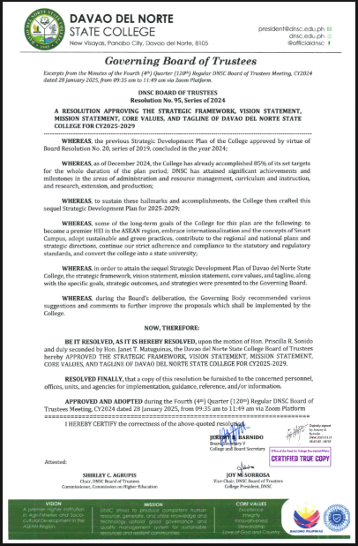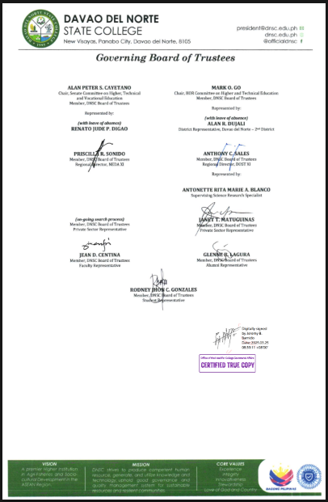

Figure 1. Screenshot of the approved BOT Resolution No. 95 series 2024.

    - VMGO (2020-2024)

The DNSC Strategic Plan 2020-2024 was approved through BOT Resolution No. 20 series 2020 where the new and revised VMGO is incorporated.

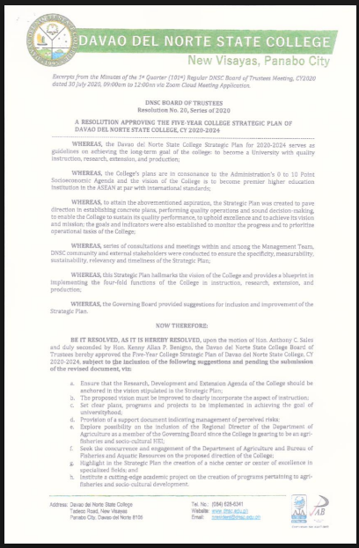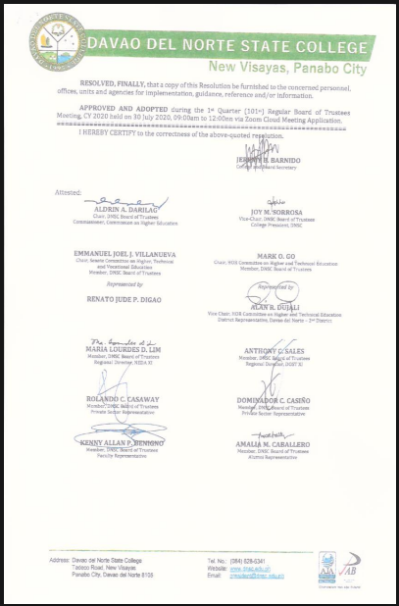

Figure 2. Screenshot of the approved BOT Resolution No. 20 series 2020.

  - Describe the results of the interview with the administration, faculty, staff and students.

Based on the consultative meeting with stakeholders, the DNSC VMGO is highly accepted by the administrators, faculty, staff, students, parents and various Local Government Units.

- BEST PRACTICES

  - Cite as many best practices as you can on Parameter A such as governance based on the principles of participation and transparency leading to the accomplishment of the VMGO.

    - Consultative and participatory strategic planning.
The 5-Year Strategic Plan of DNSC had undergone consultations to ensure that the concerns and issues of the College and stakeholders were identified and considered in crafting its VMGO that was participated by various stakeholders. Thus, it ensures the specificity, measurability, sustainability, relevance and timeliness of the Strategic Plan.

    - Consideration of SWOT and Aspiration of the College.
In the formulation of the VMGO, the Management Team considered the strengths, weaknesses, opportunities, and threats of the college.

    - Consideration of relevant trends and Philippine situations.
The formulation of vision and mission considered the present landscape of Philippine education, the global teaching and learning trends, and the internal situation and the niche programs of the programs.

    - Consideration of Local, Regional, National, International Plans and Priorities.
The formulation of Vision, Mission, Goals, and Objectives (VMGO) embodies a sophisticated synthesis of local, regional, national, and international plans and priorities, fostering alignment and strategic coherence.

    - Inclusion of Waterfall Development Methodology in Institutional Planning Process of Strategic Development Plan (SDP) 2025-2029.
The Planning Process of the College is anchored on the concept of Waterfall Development Methodology, a sequential development process that flows like a waterfall through all phases of a project with each phase completely wrapped up before the next phase begins.

    - Contribution to Sustainable Development Goals (SDG).
DNSC will foster creativity, resilience, and forward thinking to students, faculty and staff, and stakeholders with the tools to anticipate challenges and seize opportunities in an increasingly complex world. This visionary approach ensures that the college is not just preparing its community for the future ahead, but inspiring them to create it, paving the way for lasting impact and a brighter, more sustainable tomorrow.

Parameter B: Dissemination and Acceptability
dfdf

- SYSTEM – INPUTS AND PROCESSES

  - State the Forms/Media used in disseminating the VMGO.

Table 3 outlines the media and platforms used to share the VMGO with various stakeholders, demonstrating the institution’s commitment to inclusive communication. Office memos reached 303 personnel, student orientations engaged 7,211 students, and digital platforms such as Facebook and the DNSC website reached 52,000 social media followers and 10,172 website viewers as of April 8, 2025. Bulletin boards across campus informed approximately 10,000 individuals, including visitors and alumni. This comprehensive, multi-channel approach maximizes stakeholder reach and engagement.

Form/Medium | Type of Audience/Clientele | Number of Clients
Office Memo Dissemination | All DNSC Personnel | 303
Posted Brochure on FB Pages: DNSC | Students, Parents, and General Public | 52,000 followers and viewers
DNSC Website | Students, Parents, and General Public | 10,172 viewers as of April 8, 2025
Student Orientation/Class | Students | 7,211
Bulletin Boards inside and outside the college campus | Students, Parents, Visitors and Alumni | 10,000
Table 3. Summary table of the forms/media used in the dissemination of VMGO.

  - Present captioned photographs of the posted VMGO inside and outside campus premises.

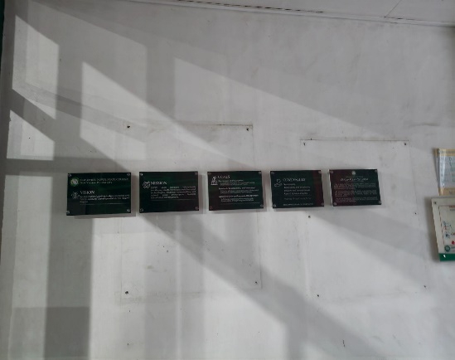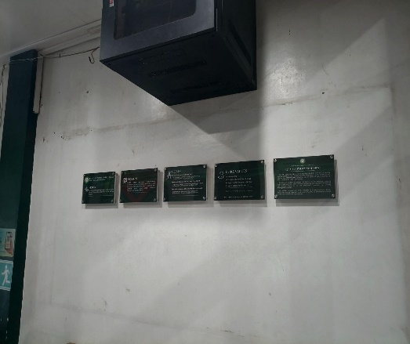
Figure 3. DNSC VMGO posted outside of New COA Office (left) and Admission Office (right).

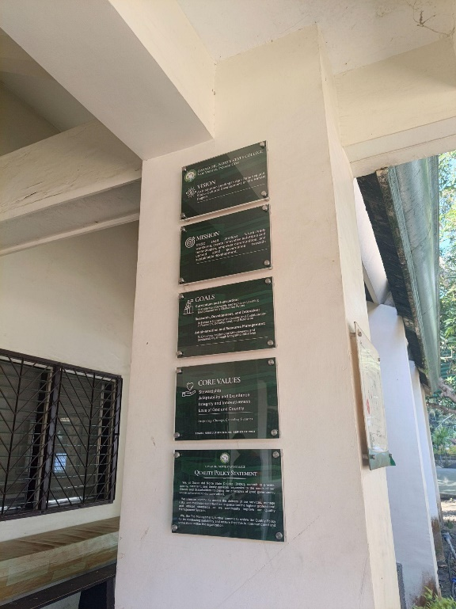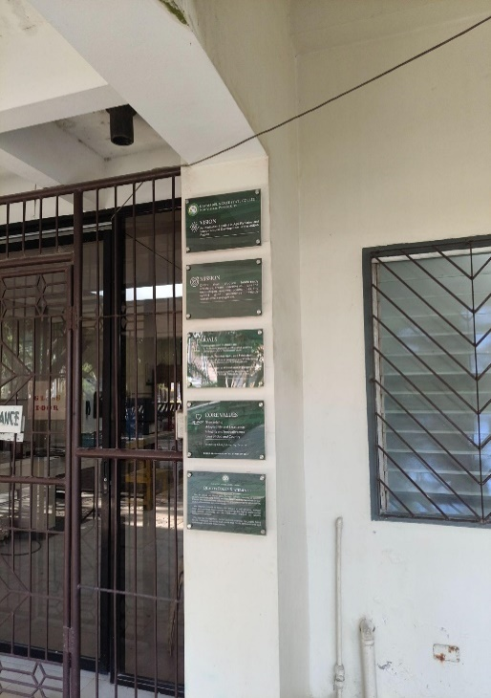
Figure 4. DNSC VMGO posted outside of canteen (left) and Natural Sciences Laboratory (right).

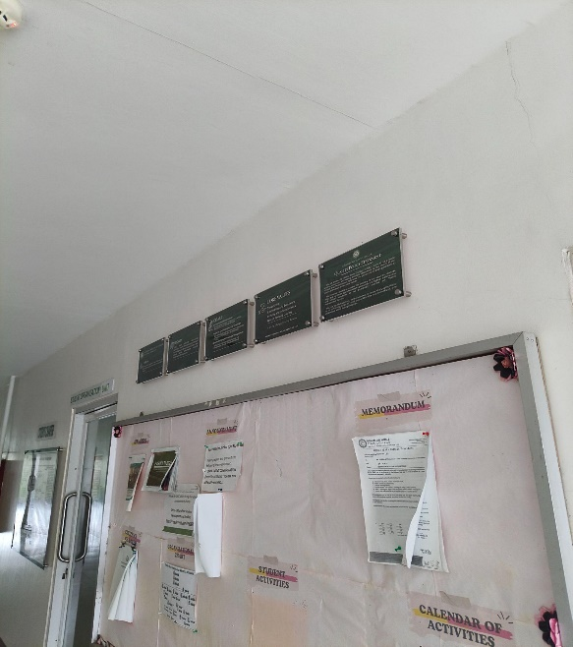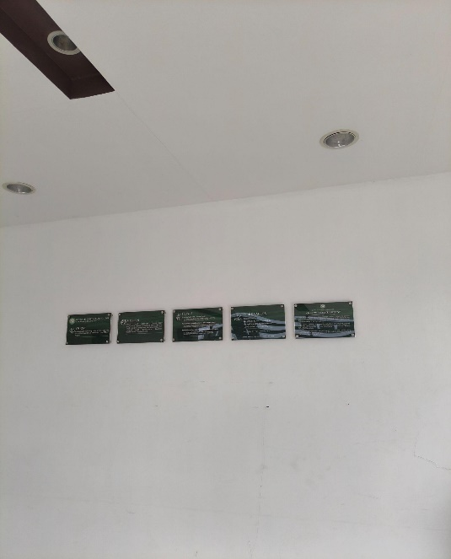
Figure 5. DNSC VMGO posted in the SDSD Director Office (left) and SDSD Lobby (right).

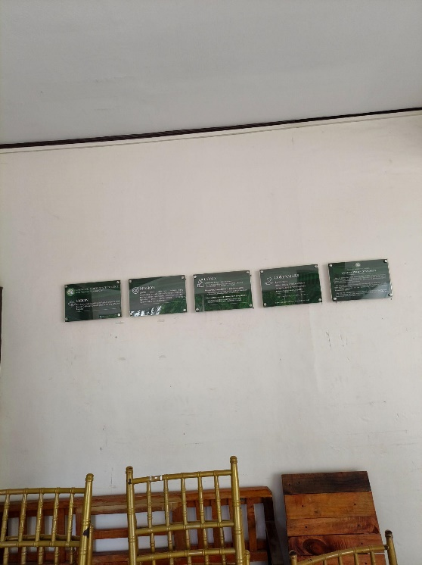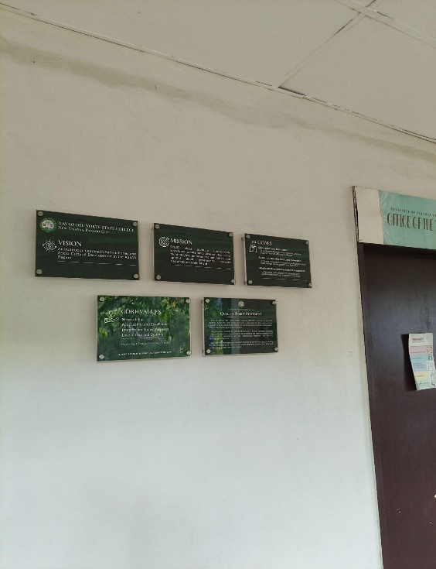
Figure 6. DNSC VMGO outside the T.H.E Building (left) and ITED Dean’s Office (right).

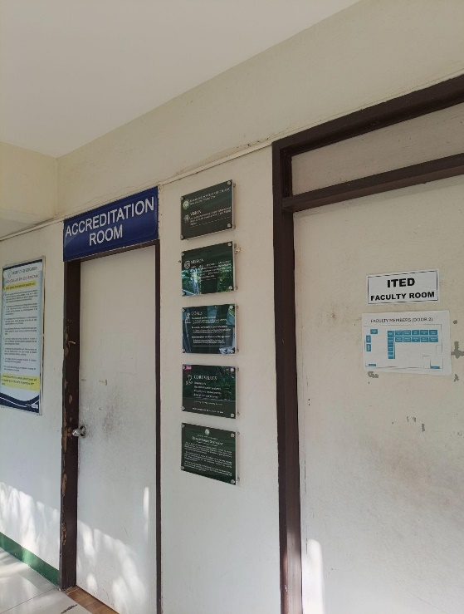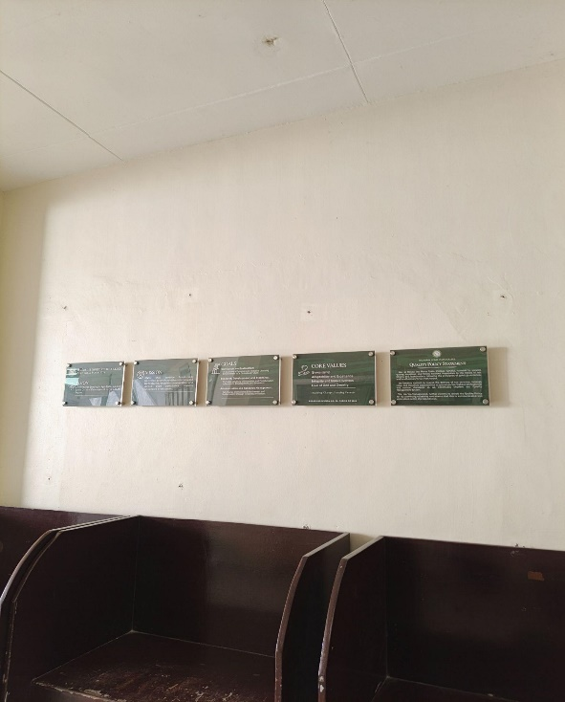
Figure 7. DNSC VMGO posted outside the ITED Faculty Room (left) and AVR (right).

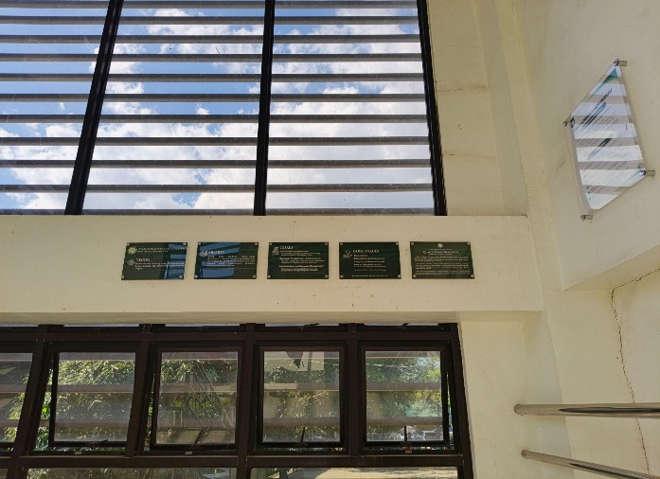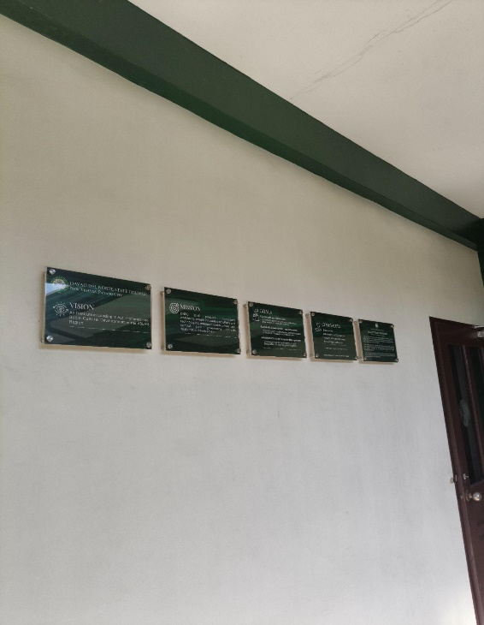
Figure 8. DNSC VMGO posted in the ILEGG lobby (left) and Science Building lobby (right).

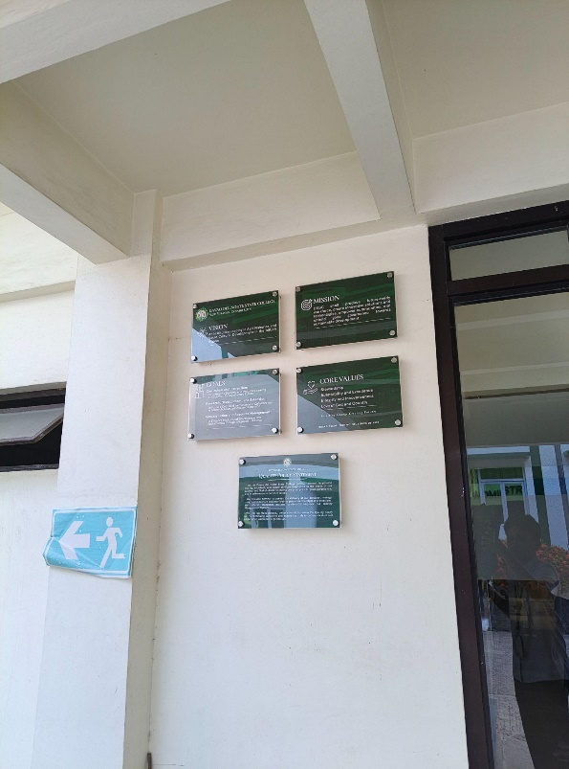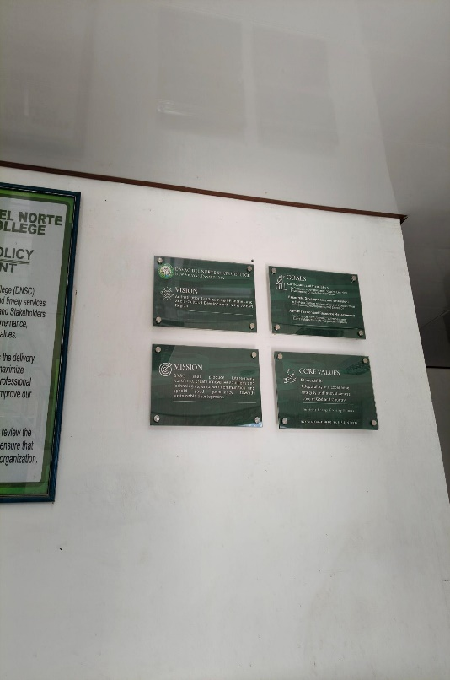
Figure 9. DNSC VMGO posted in Administration Building Entrance (left) and Guardhouse (right).

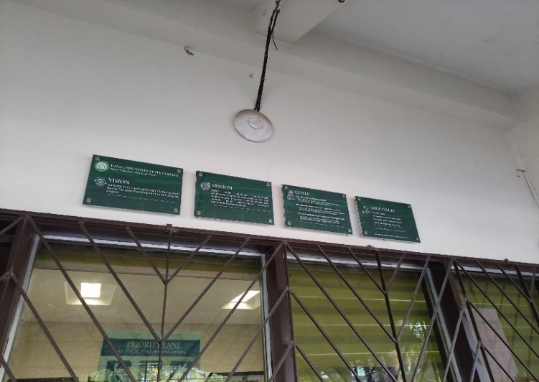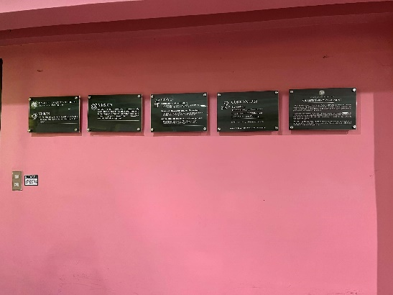

Figure 10. DNSC VMGO posted outside the Cashier’s Office (left) and IC Faculty Office (right).

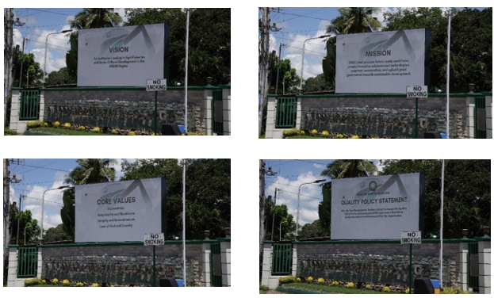
Figure 11. DNSC VMGO posted outside the Campus using the LED Wall.

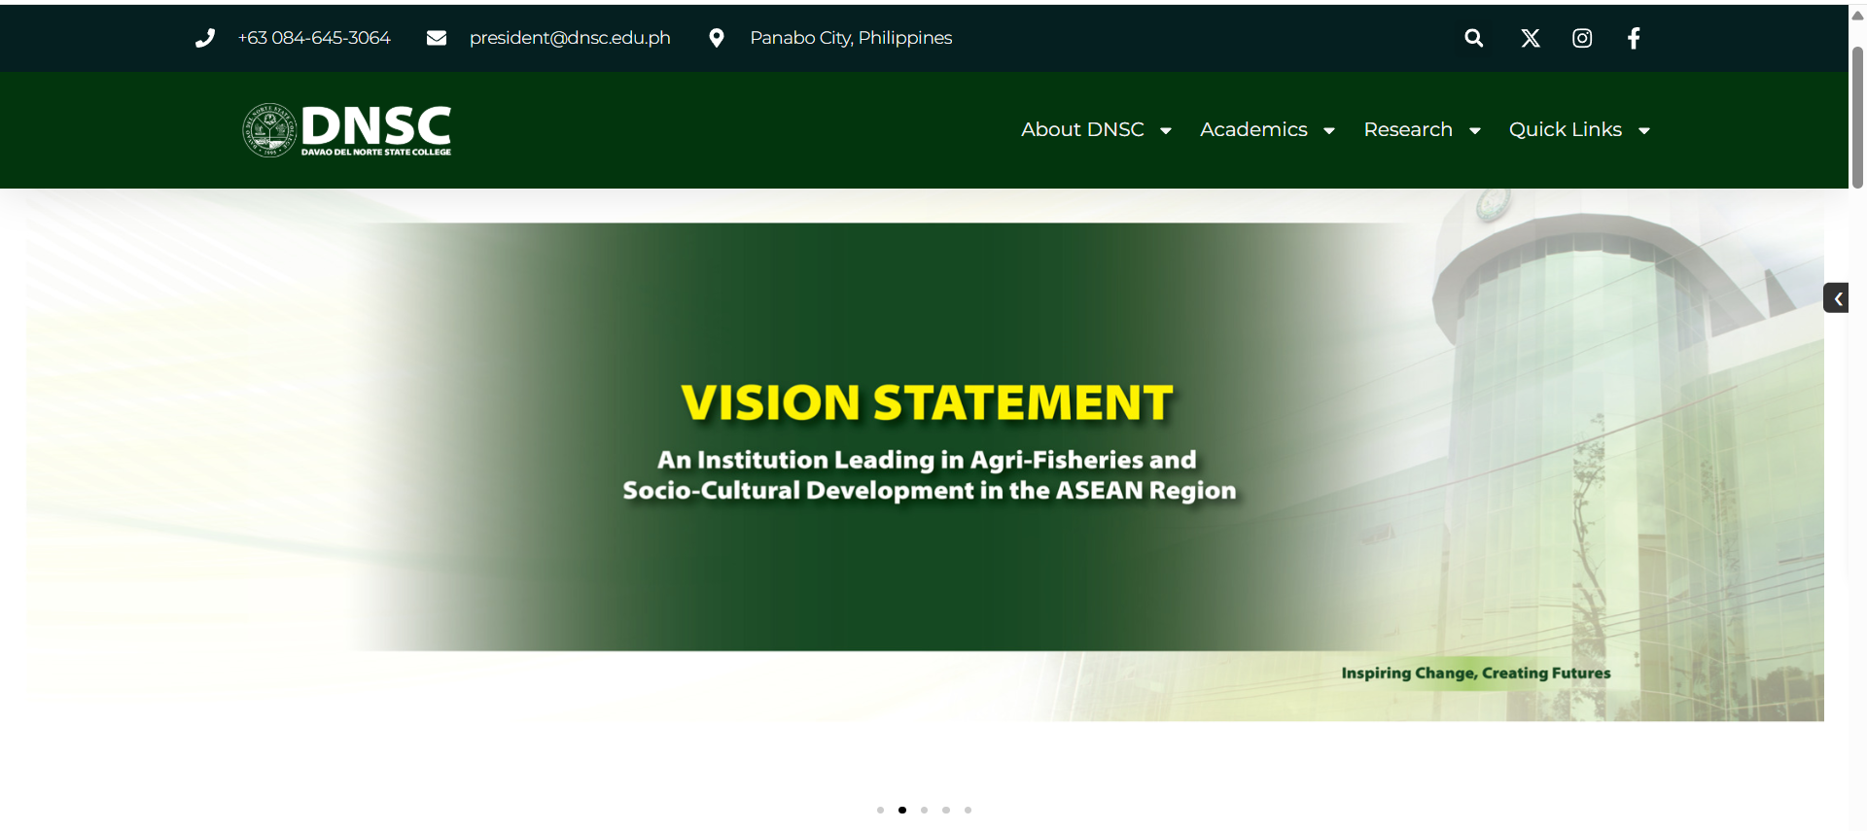
Figure 12. Sample screenshot of the DNSC VMGO posted in the DNSC Website.

  - Present documentary evidences on the participation of administrators, faculty, staff, students, and stakeholders in the formulation and review of the VMGO.

The college formulated and reviewed its VMGO through a comprehensive stakeholder consultation process. Strategic plans were developed in workshops and presentations led by the Planning Office and College Management Team, who actively gathered and incorporated feedback. Attendance records and meeting minutes confirm the participation of administrators, faculty, staff, students, alumni, government officials, and external stakeholders, ensuring diverse perspectives shaped the institution’s direction. This inclusive process demonstrates that the VMGO is a collective effort of the academic community and its partners, reinforcing its relevance and alignment with institutional and societal needs.

The documentary evidences on the participation of administrators, faculty, staff, students and stakeholders in the formulation and review of the VMGO can be accessed through this link.

Below are sample screenshots of the stakeholders’ consultations and workshops conducted.

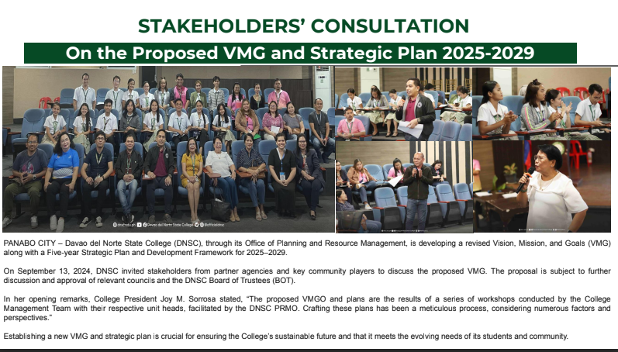
Figure 13. Stakeholders’ Consultation of the revised VMGO of the College.

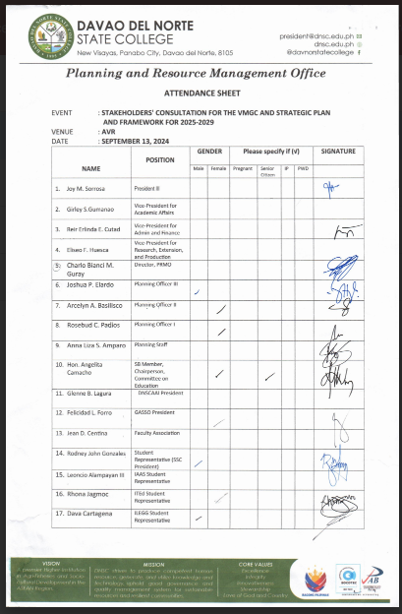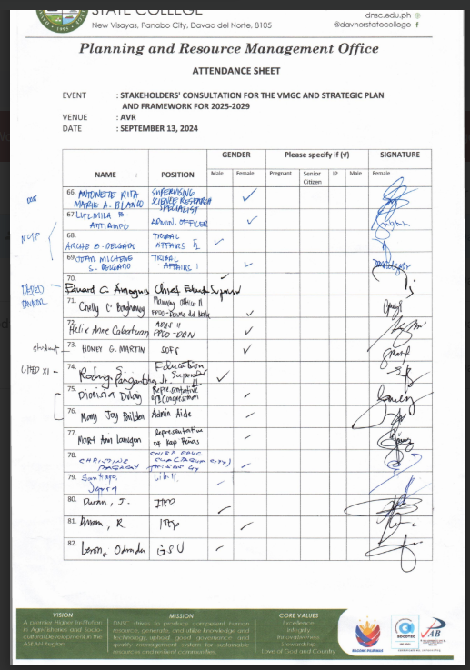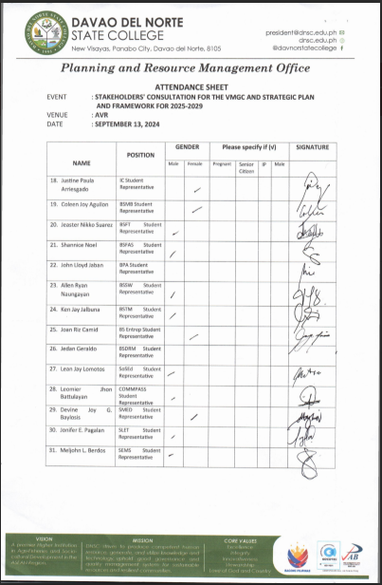
Figure 14. Sample screenshot of the Attendance sheet during the stakeholders’ consultation.

- IMPLEMENTATION

- Cite VMGO dissemination activities, and provide captions to all pictorials, if necessary.

Table 4 summarizes the key activities and supporting documents that facilitate the dissemination and institutionalization of the VMGO. It outlines a systematic process, starting with formal approvals such as the Board of Trustees (BOT) Resolution and implementation orders, which confirm the VMGO’s legitimacy. The table also highlights major initiatives, including the launch of the Strategic Development Plan, stakeholder consultations for the 2025–2029 and 2020–2024 cycles, and programs like IAdS PASINATI, all designed to engage stakeholders and raise awareness. Online dissemination through the DNSC website and supporting documents, such as acknowledgment receipts and revised memos, further demonstrates transparency and accessibility. Overall, the table emphasizes the institution’s ongoing commitment to ensuring that the VMGO is clearly communicated, well-documented, and accessible to all stakeholders.

Activities | Link to the Document
BOT Resolution s. 2024 (VMGO 2025-2029) | BOT Res. NO. 95 s. 2024 (VMGC 2025-2029)
Launching of DNSC Strategic Development Plan (2025-2029) | Launching of DNSC Strategic Development Plan 2025-2029  Launching of SDP 2025-2029_Video Presentation
Stakeholders Consultation for VMGO (2025-2029) | Stakeholders Consultation (VMGO 2025-2029)
VMGO (2025-2029) posted on the DNSC Website | VMGO (2025-2029) posted on the DNSC Website
DNSC BOT Implementation Order NO.04 (VMGO 2020-2024) | BOT Implementation Order
Stakeholders Consultation for VMGO (2020-2024) | Stakeholders Consultation (VMGO 2020-2024)
Copy of Acknowledgement Receipt on Strategic Plan | Copy of Acknowledgement Receipt
VMGO (2020-2024) posted on the website | VMGO posted in the website
Memo on Revised VMGCV (2020-2024) | Memo on Revised VMGCV
IAdS PASINATI | IAdS PASINATI Program with presentation of the VMGO
Table 4. Summary table for the VMGO dissemination activities.

- Describe how members of the Institution (administrators, faculty, non-teaching staff, students) can articulate the procedures, guidelines, and protocols of the University/College.

Upon the approval of the board, the school administration adopted, implemented and disseminated the newly approved VMGO to all stakeholders using an online platform by posting on Facebook and DNSC Website. Furthermore, it will be also disseminated in the form of printed information such as brochures and fliers, course syllabus and outline, and oral dissemination through college meetings and student orientation and classes, including the distribution of VMGO Display Boards across various offices, which are currently in the procurement process.

- OUTCOMES

- Present the results of the research study on awareness and acceptability of the VMGO by the different stakeholders.

The awareness study by Davao del Norte State College demonstrates that the institution’s Vision, Mission, Goals, and Objectives (VMGO) are well communicated, widely accepted, and effectively implemented among stakeholders. Using a descriptive-survey approach with 722 respondents, including students, faculty, staff, alumni, and external partners, the study found a very high level of awareness (mode = 4.0). This indicates that the VMGO has been successfully shared through various platforms such as social media, the college website, bulletin boards, brochures, and instructional materials. The study also reported a very high level of acceptability, showing that stakeholders understand, internalize, and support the VMGO, largely due to their involvement in its development through consultations. Additionally, the VMGO was rated as highly relevant, confirming strong alignment between institutional practices and the stated VMGO, and affirming its effectiveness as a guiding framework for the college’s operations.

To maintain and enhance stakeholder engagement, the institution will conduct another awareness study for the revised VMGO 2025–2029. A special order has appointed a project team to lead this research. The new study will use similar survey methods to assess stakeholders’ awareness, acceptability, and the relevance of the updated VMGO, while expanding participation and improving dissemination strategies. This follow-up aims to ensure the revised VMGO remains widely understood, supported, and aligned with the institution’s evolving needs, reinforcing a culture of continuous improvement and stakeholder-driven development.

Research on Awareness, Acceptability and Relevance of DNSC Vision, Mission and Goals | Research on Awareness, Acceptability and Relevance of DNSC Vision, Mission and Goals
Awareness Study Terminal Report | Awareness Study Terminal Report
Special Order (VMGO Awareness Study) | Special Order (VMGO Awareness Study)
Table 5. Summary table for the VMGO awareness and acceptability of the VMGO.

- Describe the implementation of the VMGO and their congruence with educational practices and activities.

Congruency of the VMGO with DNSC educational practices and activities can be revealed through reflecting the VMGO in course syllabi in all subjects which are discussed to students during the first week/day of class. Furthermore, faculty members conduct various assessments to gauze how the students internalize the college VGMO. Also, VMGO is disseminated mainly through different online platforms. Aside from the online platform, the college will also replace the old VMGO frames/display boards for each office and acrylic frames for conferences, pathways, rooms, audio-visual room, gym and other strategic places.

The College will print a Strategic Development Plan (2025-2029) wherein the history of the revision of the new VMGO is indicated and will be distributed to various campus offices. As practice, brochures for school campaigns will reflect the newly approved VMGO. Also, the VMGO shall be presented during academic events like charter and graduation day.

So much initiatives have been made to attain the VMGO, to name a few: attending conferences and having awards in paper presentation including the graduate studies faculty members, various initiatives in building partnership locally and internationally, purchasing school facilities to improve its efficiency, school pursuits of quality assurance by developing its quality assurance office and maintaining its ISO certification, having gender and culture sensitive initiatives and the college received a the first place award for its disaster preparedness and resiliency efforts and programs in the province for its mission to develop a resilient community.

- Cite instances or evidences to show that program goals/outcomes and objectives are achieved.

The Master in Information Technology program achieves its Program Educational Objectives (PEOs) and Program Outcomes (POs) through a range of academic, research, and extension activities. Graduates demonstrate proficiency in developing, using, and integrating emerging technologies, as evidenced by their capstone projects in networking, data management, software engineering, information security, and other related fields. Systems development projects and case studies further confirm students’ ability to analyze complex problems and implement IT-based solutions that meet industry standards and best practices.

To support professional growth and lifelong learning, students and graduates participate in research presentations, seminars, colloquia, and other development activities. For example, MIT students attended a graphics design seminar-workshop led by Mr. Pravin Bajaj, where they learned industry-relevant tools and concepts through hands-on activities and presentations. Students also regularly present their completed capstone projects at colloquia, demonstrating their ability to communicate technical results, defend their work, and respond to feedback. These experiences showcase students’ skills in articulating ideas, collaborating, and applying knowledge in practical, industry-aligned contexts. Communication and collaboration are further strengthened through project defenses, research presentations, and group activities with diverse audiences. Ethical, legal, and social responsibilities are integrated into coursework, institutional policies, and research protocols, ensuring graduates uphold professional standards and understand the broader impact of computing on society.
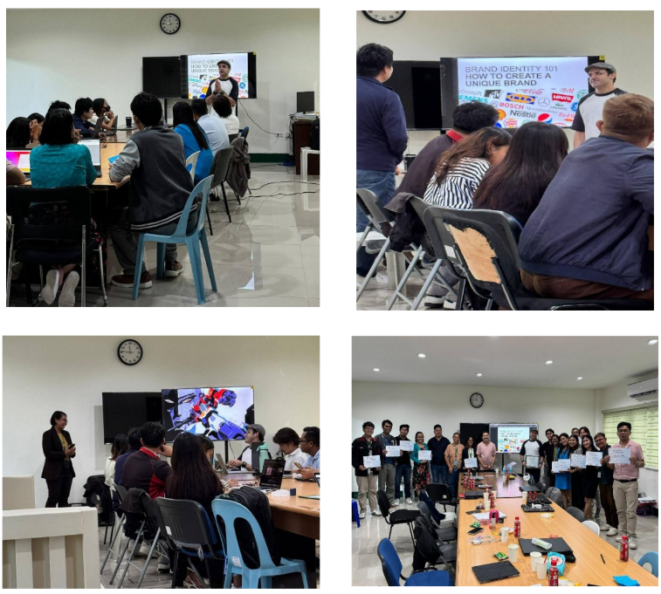
Figure 15. Photo of MIT students attending the graphics design workshop with Mr. Pravin Baja.

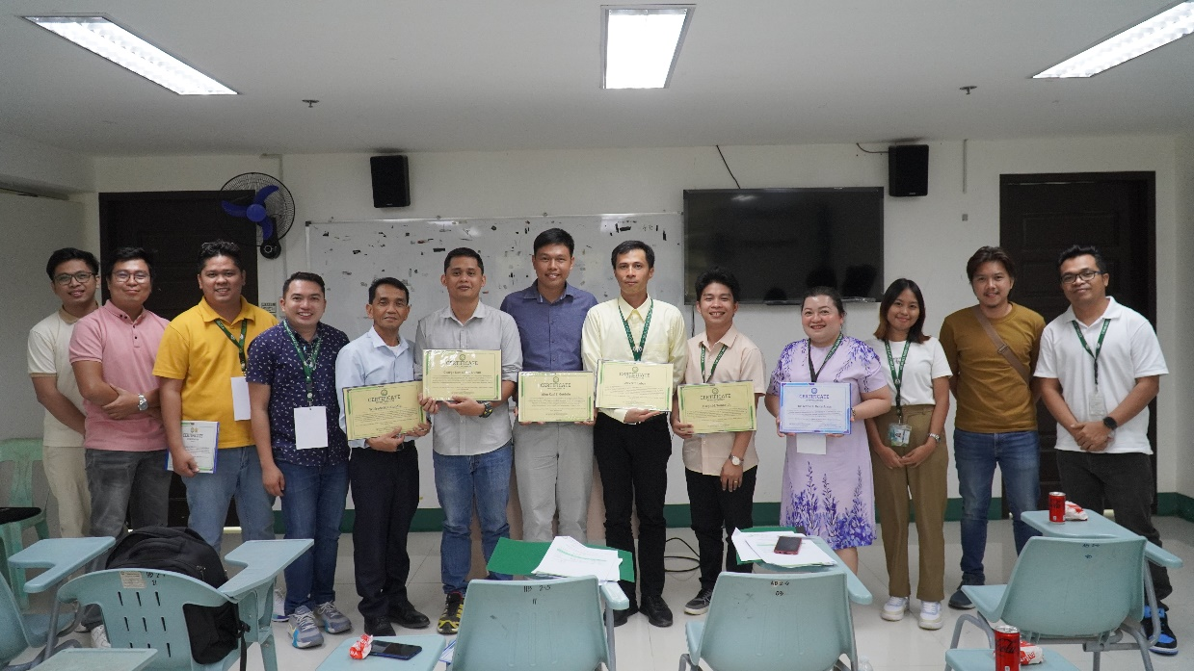
Figure 16. MIT graduating students presented their capstone project during the 2025 Colloquium.

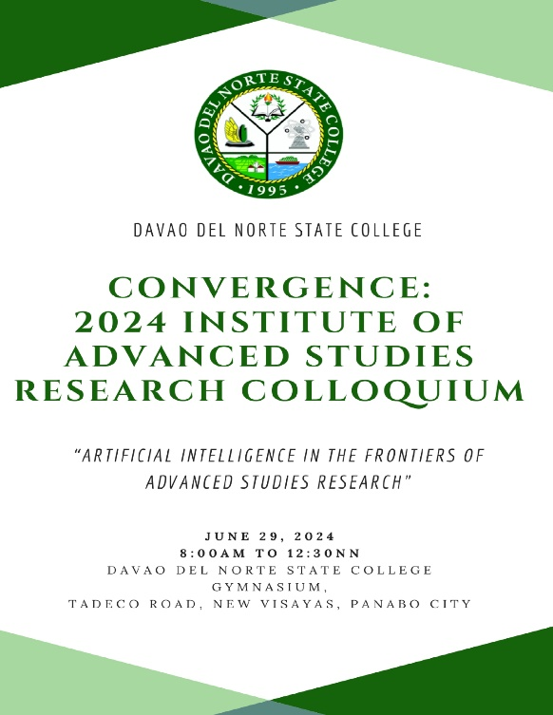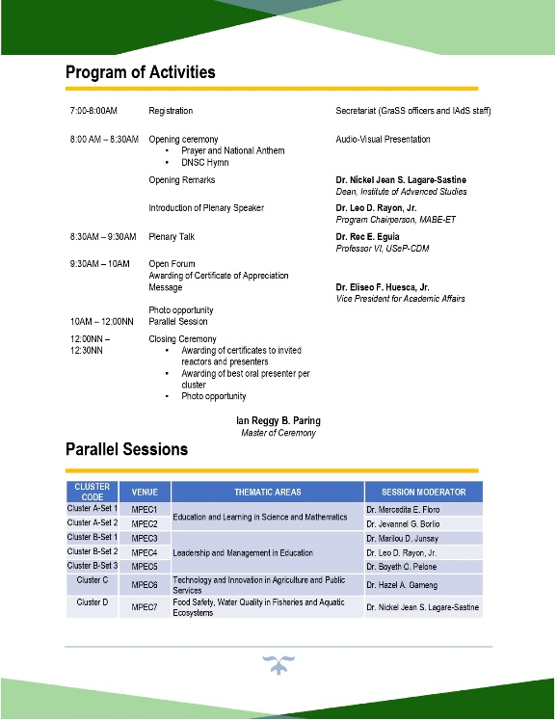
Figure17. Program of the 2024 Research Colloquium.

- BEST PRACTICES

- Cite as many best practices as you can on Parameter B such as governance that facilitates the accomplishment of the VMGO.

Listed below are the best practices on Parameter B.

    - Utilization of Website and other social media.
The College utilized its website and other social media accounts to inform the stakeholders on the revised VMGO, thus it is considered as an effective platform of communication in this time of pandemic.

    - Visibility of VMGO inside the campus.
The DNSC VMGO is visible in various strategic places inside the school campus such as pathways, AVR, gym, different offices, gate, classrooms and hostel and the school used frames made of acrylic frames to maintain the physical quality of the displayed VMGO.

    - Integration of VMGO in Class.
As practiced, VMGO is being discussed on the first day or week in class and faculty apply various forms of assessments to measure the students’ knowledge and understanding of the VMGO.

    - Production of Strategic Plan for 2020-2024.
The College produces a copy of the Strategic Plan for 2020-24 Journal to facilitate the dissemination of the VMGO and the college plans for the year 2020-24.

    - Production of Strategic Development Plan (2025-2029).
The College is currently in the process of procuring a copy of the Strategic Plan for 2025-29 Journal in to facilitate the dissemination of the new VMGO and the college plans for 2025-29.

    - Alignment of College Initiatives to the VMGO.
The initiatives of the College congruent to its VMGO.

- BEST PRACTICES

- Present the status of compliance matrix of the area focusing on the interventions done on the recommendations.

The program is currently undergoing its first survey visit; hence, there are no prior compliance findings or recommendations from any previous preliminary survey visit to report or address.

